**The Design Thinking Process and Activity Packet**

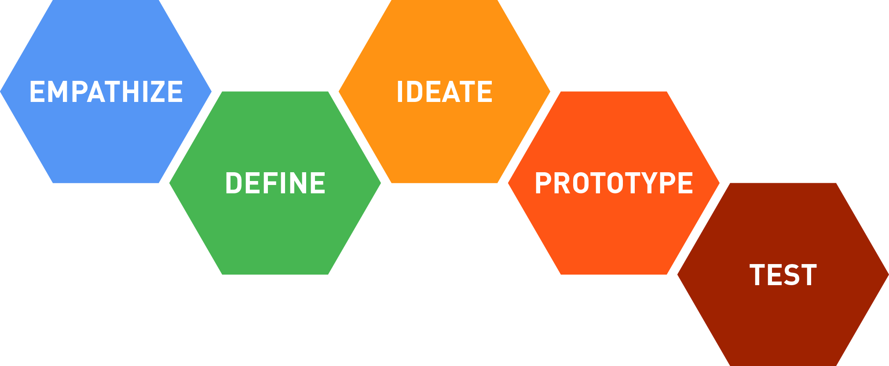

**Before you start this activity:**

Select a partner, someone in your final project group, and form a team of 2

(If your final project group has 5 people, there can be one team of 2 and one team of 3)

Setup about an hour for you and your partner to meet on Zoom or similar tool to complete this assignment

It is suggested that you print this packet and use a pen/pencil to fill it in, each person should fill out their own packet and be ready to submit it on Canvas later

Designate one person as partner “A”, and the other as partner “B”  
(If you have a team of 3 people, make one person “A”, and the other two as “B”)

Have your phone or a clock nearby to time each activity and don’t go longer than told  
   
Turn on your video (if you have a webcam) and mic when you meet with your partner(s)

**Goal: Experience the “Design Thinking Process”.**

We will use the “Design Thinking” method to consider ways that we could improve the UW registration system. Think about the last time you registered for classes – start to finish (everything from using MyPlan, talking to an advisor, asking friends, to actually registering and getting a set of courses that you are officially enrolled in). What was your overall experience like? Was it smooth, did you have frustrations, were their things you wish you could have done that you couldn’t, information you wished you had that wasn’t available, were you happy in the end?

You have personal experiences but remember, you are not designing for yourself, you are **designing for your partner(s)** through this process.

The goal is to make **some part** of the overall UW registration process better next time *for your partner(s), not for you.*

Start by gaining **empathy**, what was your partner’s experience like the last time they registered for classes? Partner A interview B (3 minutes) then switch, B interview A.

A: Hairong Wu (Jason); B: Zhuoyan Liu (Louise)

|  |  |  |
| --- | --- | --- |
| **1 Interview** – 6 minutes (2 sessions x 3 minutes each). Notes:  Can find anything that you would want?  A: Can find courses that are not offered in this quarter.  When registering on MyPlan, it would jump to Register Using SLN. |  | **2 Dig deeper** – interview again. What stood out? probe, pay attention to emotions/feelings expressed (2 sessions 3 minutes each). Notes:  Language would express confusion while talking about some drawbacks. Sometimes the accent of B would be depressed or angry while taking about the disadvantage of MyPlan. |

**Reframe the problem – by yourself, complete 3 and 4 based on your interview.**

|  |  |  |
| --- | --- | --- |
| **3 Capture findings** – 3 minutes  **Needs:** things they are trying to do (use verbs)   * Find courses * Register; * Arrange course schedule   **Insights:** new learnings about your partner’s feelings/view to leverage in your design (make references from what you heard) |  | **4 Define problem statement** – find most compelling things from left side and summarize here. 2 minutes  Louise / Register courses  partner name/description  Needs a way to _Directly register in MyPlan without jumping to Register using SLN_______  user’s need  Surprisingly // because // but… (circle one)  The whole registration process would failed if one course failed to be registered. Thus, the user may have to come back to MyPlan to rearrange and then jump to Register Using SLN again to finish their registration.  insight  Insights are nuggets that you might leverage in design but you don’t know how it might be important yet. Often are things that are emotional or personal, e.g. their mother is ill and needs them to be home each morning. |

**Ideate:** generate alternatives to test – 4 minutes

**5 Sketch/draw 4 ways to meet your user’s needs (avoid writing)**. Do this individually and do not share with your partner yet. Don’t worry, most of us are not artists, do your best.

Write your problem statement above

|  |  |  |  |  |
| --- | --- | --- | --- | --- |
| No Need to have a Register Using SLN website | Have an inner screen in MyPlan to show the Register Using SLN website, instead of jumping to a new site. | Would directly register those courses without conflicts, and then leave those with conflicts. | Would notify courses that you don’t meet the pre-requisite or having conflicts before you are ready to register. |  |

**6 Share your solution with partners and capture feedback** - 6 minutes (2 sessions x 3 minutes each). What do they like, not like? It is not about the quality of drawings, all about the ideas.

|  |
| --- |
| Notes:   * Good that there’s no need to have a Register Using SLN website. |

**Iterate based on feedback. Do this individually, not with your partner.**

**7 Reflect and generate a new solution –** 3 minutes

|  |
| --- |
| Sketch your one big/best idea from all those you had before and create a prototype. Note details if necessary, can use text here if it helps explain   * The new registering system in MyPlan would highlight/notify those courses that you really don’t meet its pre-requisite or having conflicts. * While you are ready to register, it won’t open a new window which jumping to register using SLN, but have a window that would show the Register Using SLN screen. |

**8 Test – share your solution with partner(s) and get feedback.** 6 minutes, 2 sessions x 3 minutes

|  |  |
| --- | --- |
| What worked?   * Registering the whole schedule * Knowing conflicts | What could be improved?   * Arranging course schedule * Register courses |
| Questions they had…   * How the conflicts would be shown * How the conflicts would be calculated | Further Ideas…   * To eliminate the Register Using SLN and combine the function to MyPlan. |

**Final reflection questions, complete individually:**

Is this process how you would normally solve a problem?  
- Find the problem first, then looking for ideas. While having an idea, see whether it improve the problem, or do the same, or even increasing more problems. Then resolve those issues, and try to produce a prototype, which can be uses and receive feedbacks from real practice. Maybe do the steps above again, and then it is ready to be finalized.

Is the solution you came up with for your partner, the same solution you would have come up with for yourself?   
- Yes. We almost think together to resolve the problem; for instance, we all find drawbacks of the registration process on MyPlan.

Do you think the “Design Thinking Process” let you see something about this problem that is important to others, but you hadn’t previously considered?

* Yes, I do learn more ideas from my partner that I haven’t consider; for instance, I don’t think about combine the Register Using SLN to MyPlan, but instead I only think about opening that website without jumping to a new tab.

Submit this entire packet to Canvas for the Design Thinking activity. It can be a Word file, you can scan it as a PDF, take pictures with your phone, whatever method works for you but we want to see that you completed all the questions to get credit.